Child-Welfare Analyst: Arizona's High Foster-Care Rates Not Getting Any Better
By Matthew Hendley Fri., Mar. 14 2014 at 10:48 AM
5 Comments
Categories: News

The thousands of ignored allegations of neglect and abuse that went uninvestigated isn't the only crisis Arizona's Child Protective Services is dealing with.
This morning, the CPS oversight committee at the Legislature brought in a child-welfare expert to explain some statistics surrounding the number of Arizona kids that are placed in out-of-home care.
See also:
-CPS Chief: Agency Tried to Hide Growing Backlog of Cases
The number of kids in foster care has been increasing for several years now, and the chart below gives the best look at the problem Arizona's facing. The number of kids going into out-of-home care is much higher than the number of kids leaving. In the vast majority of states, more kids have been leaving the system than entering.

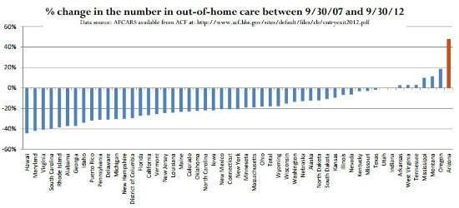
That's Arizona, on the far right.
Bryan Samuels, the former commissioner of the federal Administration on Children, Youth and Families, and the former head of Illinois' child-welfare agency, explained the many ways in which other states do things differently. And from every angle, Arizona's system isn't looking up.
In recent years, kids have been staying in state care longer and longer.
In 2006, 74 percent of kids who entered foster-care system entered it for first time, while the remaining 26 percent were making at least their second visit.
Since then, that number has hardly changed.
"If keeping them longer was good, then [the number of kids returning to out-of-home care] would go down," Samuels said. "What's striking about your numbers is how consistent they are."
That's important not only because it's just plain not good to keep kids out of their homes for longer periods of time, for a variety of reasons, but the dollars and cents don't add up. It costs a whole lot less for CPS to provide services at the "front end," like intervention with the family, than it does to keep a kid in foster care.
"If [the numbers of kids returning to foster care] were up and down, you would imagine that that's a reflection of performance improving, or sometimes dipping," Samuels said. "There's such little variation in your numbers, that suggest that there's little movement in choices you've made . . ."
Of course, one of Governor Jan Brewer's main policy points is her championing of various CPS reforms. The rate of foster care -- which is not a new discovery by any means -- coupled with the scandal of uninvestigated cases, aren't indications that CPS has been operating better over the last few years.
There are an incredible number of factors that might affect the rate of kids going into foster care. Just a few months ago, the Arizona Daily Star took a look at how much various funding cuts were influencing the problem, for example.
Samuels pointed out a few other possible indications. For one, Arizona actually has an increase in neglect cases, and since the criteria for a CPS investigation varies state-to-state, Arizona's agency tends to investigate a larger number of cases. Obviously, with those ignored cases, and the growing backlog, CPS isn't responding to these cases as quickly, either, perhaps complicating how much of those "front end" services CPS can provide.
Many of these problems regarding state care aren't unique to Arizona, Samuels explained, but they just happen to be compounding here.
"None of these problems is insurmountable -- that's the good news," Samuels said.
Meanwhile, the Legislature is considering several proposals offered as CPS reform. While there's a call for an audit of CPS, and lawmakers already approved more immediate funding to hire more workers, Governor Brewer has recommended nearly $74 million in new spending for CPS in next year's budget.
Got a tip? Send it to: Matthew Hendley.
Follow Valley Fever on Twitter @ValleyFeverPHX.
Follow Matthew Hendley at @MatthewHendley.

